***PAAREES PERFUMES***

***VERSACE***

***FOR MEN***

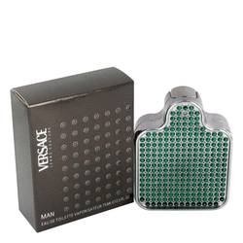

# 

***JEANS COUTURE***

## *Description:*

Jeans Couture by Versace Cologne. Bask in the distinctive scent of Jeans Couture for men any time you want to stand out. Created by the design house of Versace in 2002, this sublime fragrance blends the spicy notes of cardamon and nutmeg with mandarin orange, myrtle and bergamot to produce a masculine scent that is as equally attractive with sportswear as it is with formal attire. Wear it on Casual Fridays, to the golf course or out for a night on the town